**East Clothing: E-commerce Application**

The repository **Mern-Ecommerce-website** is a full-stack e-commerce platform built using the MERN stack (MongoDB, Express.js, React.js, Node.js), along with Redux for state management and Chakra UI for styling. It supports both client-side functionality and an admin panel for managing products, users, and orders.

It also notes that when logged in as an admin, a special navbar button appears to access controls for products, users, and orders, with capabilities like editing, adding, and marking orders as delivered

**TECHNICAL ARCHITECTURE:**

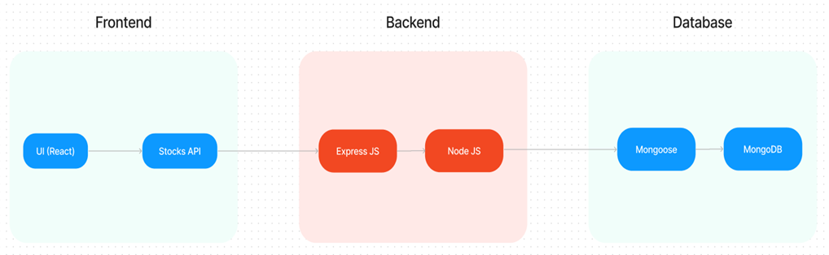

In this architecture diagram:

• The frontend is represented by the "Frontend" section, including user interface components such as User Authentication, Cart, Products, Profile, Admin  dashboard, etc.,

• The backend is represented by the "Backend" section, consisting of API endpoints for Users, Orders, Products, etc.,It also includes Admin Authentication and an Admin Dashboard.

•  The Database section represents the database that stores collections for Users, cart, Orders and Product.